**Problem Statement.**

Our case study is based on a computer hardware business which is facing challenges in dynamically changing market. Sales director decides to invest in data analysis project and he would like to build power BI dashboard that can give him real time sales insights.

**Data Discovery**

we will cover project planning and data discovery aspect of our sales insights data analysis project. Once sales directory of atliQ hardware has decided to invest in data analysis project he will do a meeting with IT director, data analytics team to come up with a plan. They will use AIMS grid to define purpose and success criteria of this project.

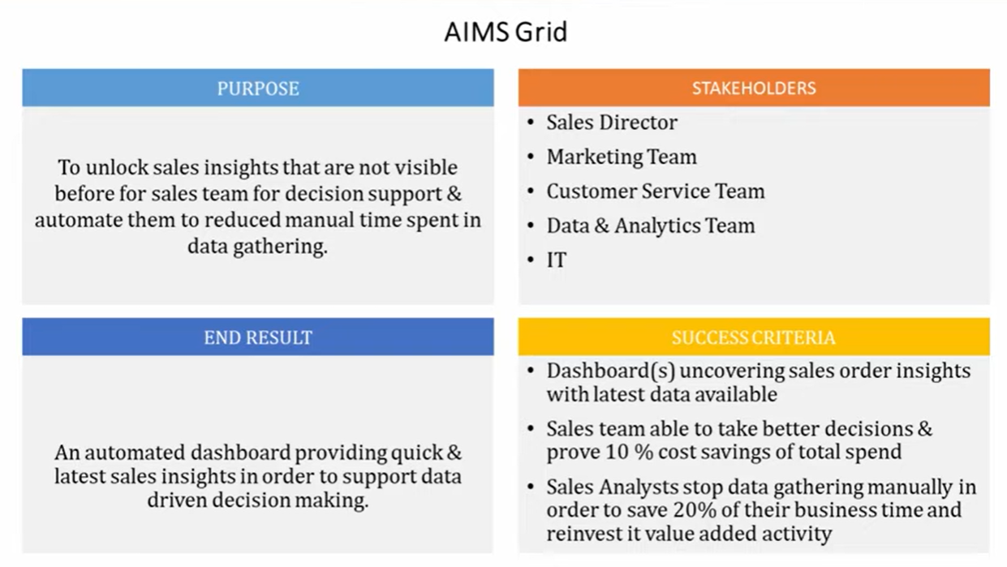

Software developer Team Manage this software - After printing the invoice of Hardware sell , all data will store to the Mysql Database. Developer team has access to the database, so Analytics team requested developer team to give access to the database to analyze the sales insight because it was very difficult for leadership to understand the business insight to see the plenty of excel file which is provided by department head.

So leadership wanted analytics team to make dashboard for sales insight.

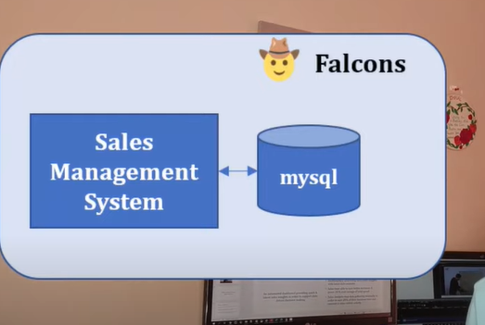

Data Master team _ data analyst team now reach out to the Falco software developer team to use their MySQL database to see the insight of the business because this all sales data is stored in the database.

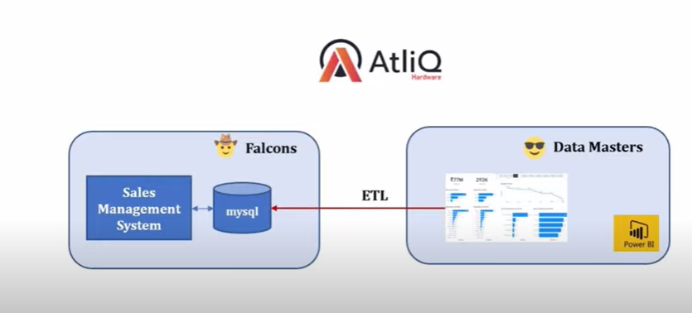

When you use the MySQL – OLTP (online transaction procession system)- very critical system -database to do the analytics, you can’t affect the database with the query you are using in power BI because it is in production it can’t be down. So many people use Datawarehouse.

They Pull the data from OLTP and do all the transformation which is called – ETL (extract, transform, load) – after transform they store the data on Datawarehouse. There so many Datawarehouse like era data and snowflakes. For transformation they use Pandas, python.

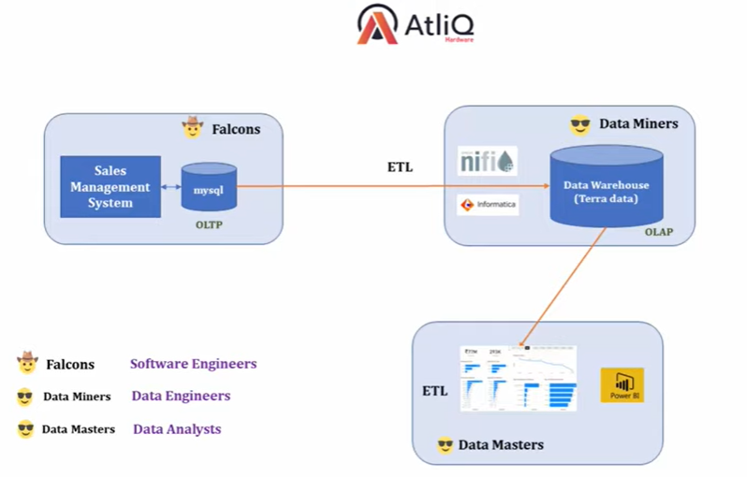

**Data Cleaning/ Data merging/ data wrangling:**

we looked at data discovery for our sales insights data analysis project. In this video, we will look at mysql database that is owned by the falcon’s team. This database has all sales transactions, customers, products, and market information. We will analyze this database and then hook it up with power BI. In power BI we will perform ETL and data cleaning operations to make it ready so that we can build our dashboard.

we will plug MySQL database with Power BI. In power BI we will do data cleaning and ETL (Extract, transform, load). This process is also known as data munging or data wrangling. We will do currency normalization, handle invalid values, etc.